**Lab 1**

1. Check if your processor supports Intel/AMD virtualization technology. Enable Intel virtualization technology in BIOS if possible.

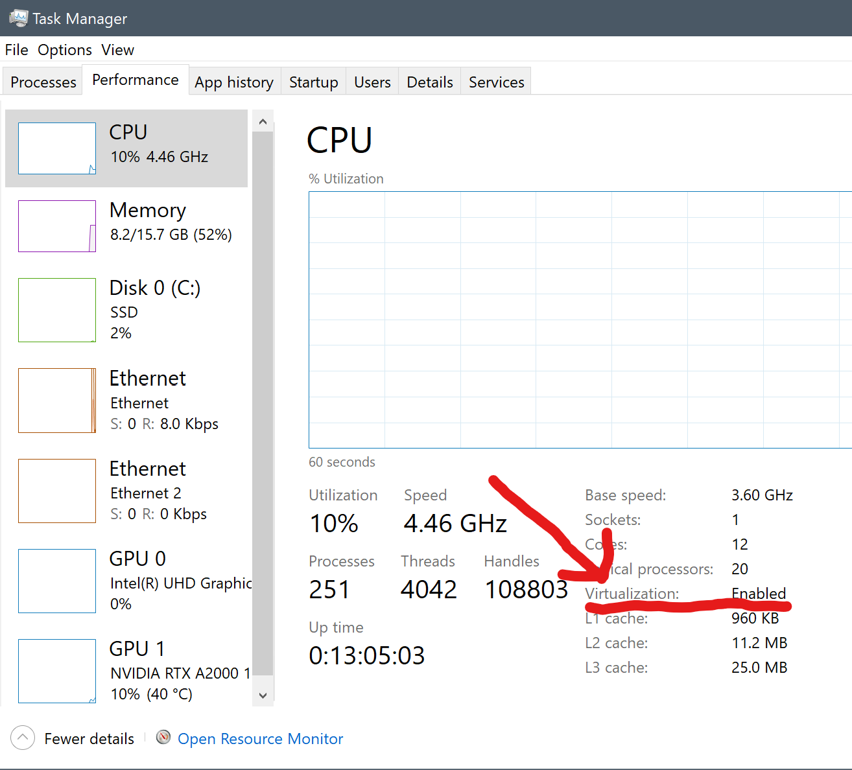

1. The cloud is almost everywhere in our lives now. What do you think are the fundamental reasons behind its success? Name three pros and three cons of cloud.

**Pros:**

**Scalability** – No need to purchase additional hardware to run online services, especially helpful for start-ups and small businesses planning expansion that may experience fluctuating traffic.

**Maintenance** – No need to have onsite server technicians building and maintaining infrastructure as that is provided in the cost of the cloud services.

**Accessibility** – Cloud servers can be set up, monitored, scaled up, scaled down and updated from anywhere in the world with internet. Allowing a Irish company for example to have local servers in America, Asia, Africa and Australia as well as Europe reducing latency for users on those continents without needing to set up dedicated server farms in those places.

3. What is the primary function of a hypervisor in virtualization?

4. What is a virtual machine (VM)?

5. What are the benefits of using virtual machines?

6. List five use cases of virtual machines.

7. In virtualization, what is the guest operating system?

a) The main operating system running on the physical machine

b) The operating system installed on a virtual machine

c) The operating system running on a remote server

d) The operating system running on a mobile device

8. What does virtual machine isolation mean?

a) Virtual machines can communicate directly with the physical hardware.

b) Virtual machines share the same resources and cannot be isolated.

c) Virtual machines run independently and are isolated from each other and the host system.

d) Virtual machines can only be accessed locally.

9. What is the benefit of virtual machine portability?

a) It allows virtual machines to communicate with each other easily.

b) It ensures faster boot times for virtual machines.

c) It allows virtual machines to be moved between different physical machines with compatible hypervisors.

d) It reduces the need for hardware virtualization.

10. What is the purpose of cloning a virtual machine?